# **Time Complexity**

Minimum time 🡪 O(1)

Maximum time 🡪 O(log n)

# **Search an element that is present in the list**

Search element 🡪 42

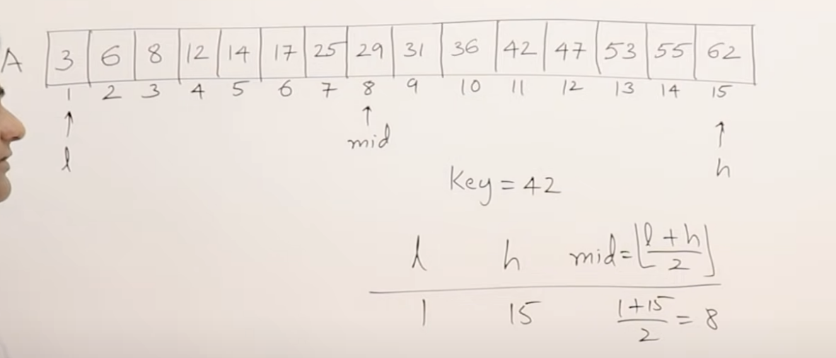

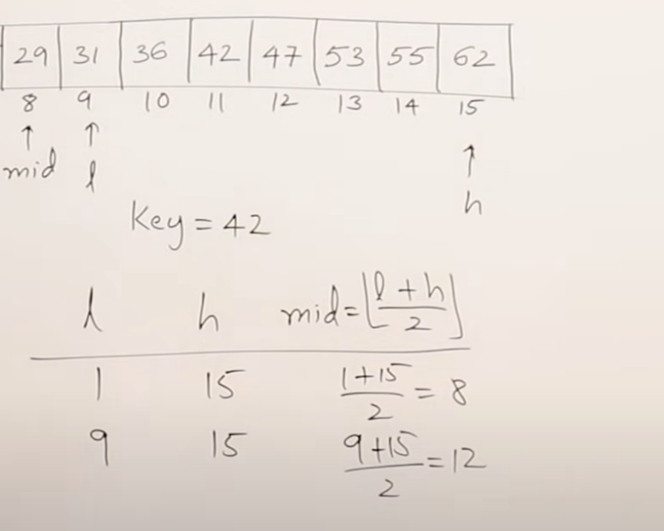

Now low = middle + 1

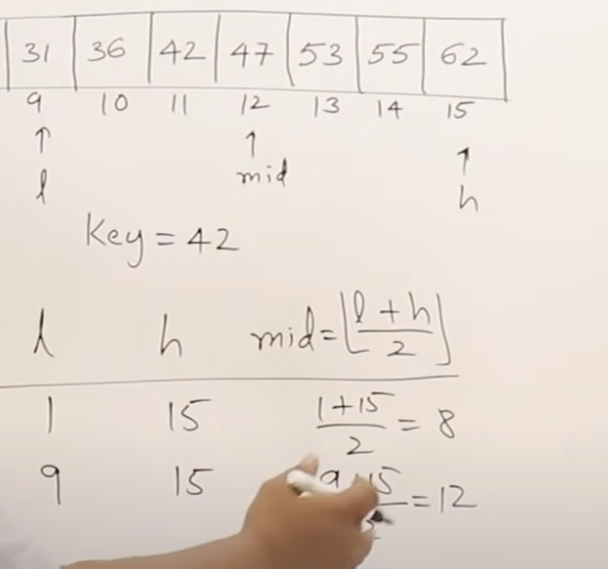

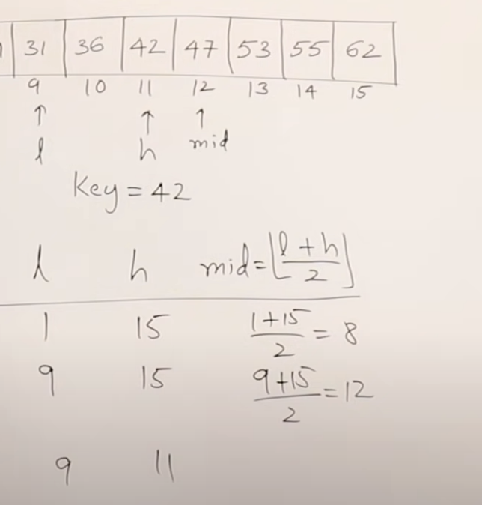

high = middle – 1

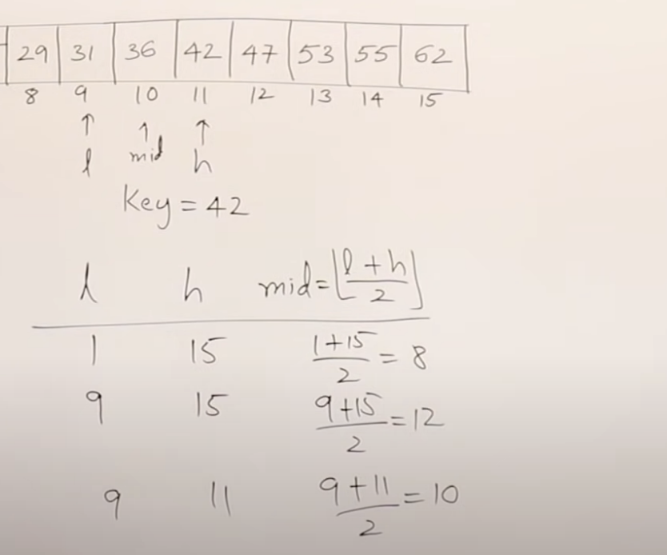

Now low = middle + 1

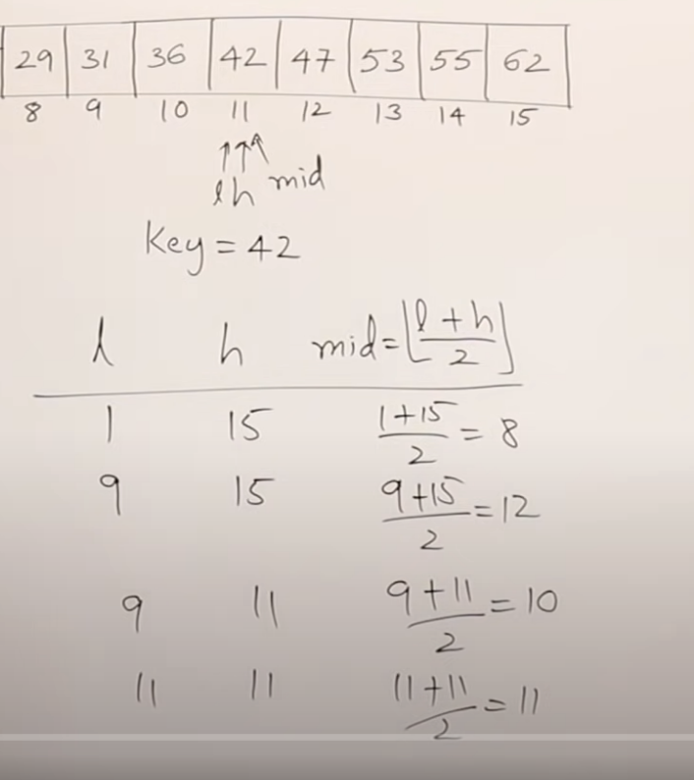

Now low = middle = high 🡪 element is found

At 4 comparisons, I found out the element

# **Search an element that is not present in the list**

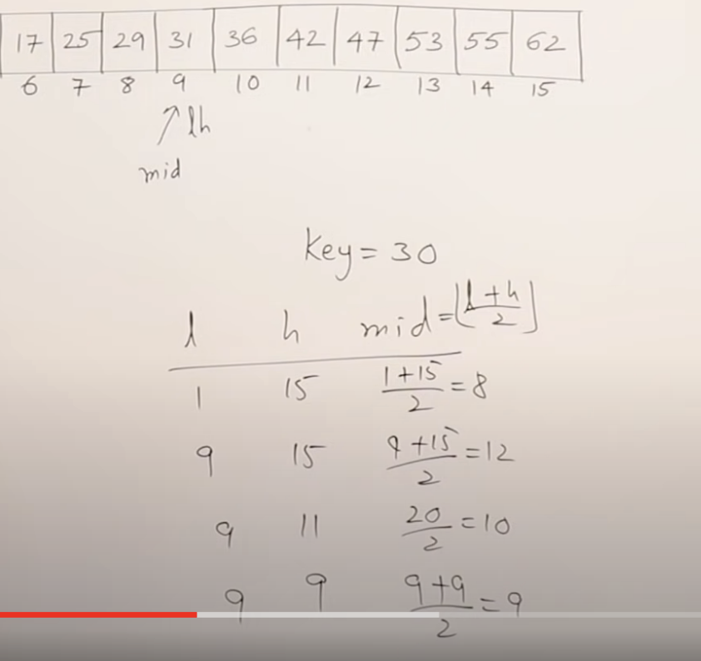

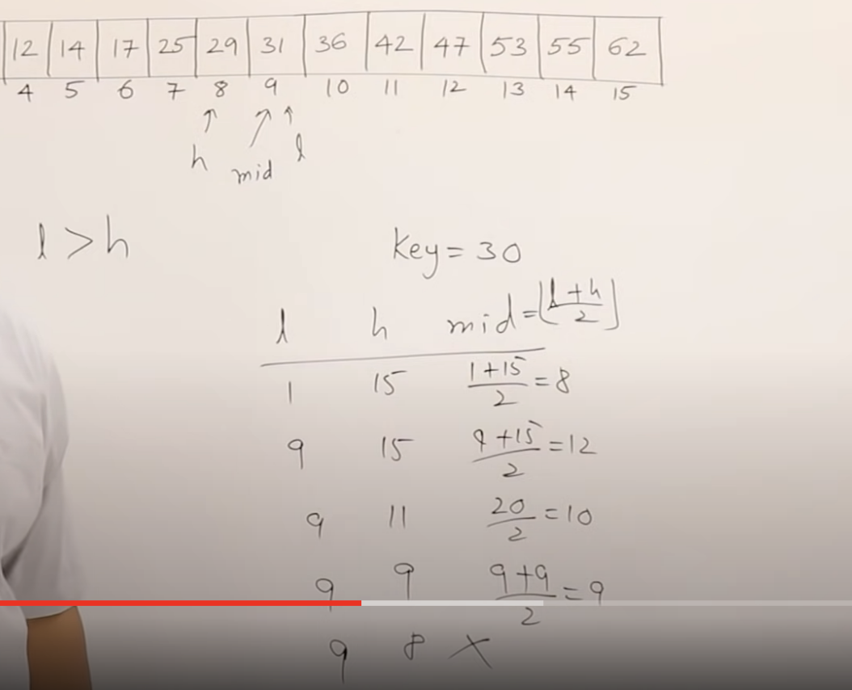

If low>=height, then the algorithm stops working.

# **Algorithm**

